4 stage pipeline

PROGRAM:

#include<stdio.h> void main(){

int counter=0;

int input;

int num1,num2;

int op;

int res;

int ins;

int performance_measure=0;

printf("\n Enter 1st value:

");

scanf("%d",&num1);

counter+=1;

printf("\n Enter the 2nd

value: ");

scanf("%d",&num2);

counter+=1;

printf("\n Enter the option: \n1)Addition\n2)Subraction\n3)Multiplication\n4)Division");

scanf("%d",&op);

switch(op){

case 1:

printf("Performing

addition operation");

res=num1+num2;

counter+=1;

break;

case 2:

printf("Performing

subraction operation");

res=num1-num2;

counter+=1;

break;

case 3:

printf("Performing multiplication operation");

res=num1*num2;

counter+=1;

break;

case 4:

if(num2==0){

printf("\n

Denominator can't be zero");

}

else{

printf("Performing

division operation");

res=num1/num2;

counter+=1;

break;

}

default:

printf("Invalid

case...");

counter+=3;

break;

}

printf("\n CYCLE VALUE IS :

%d",counter);

printf("Enter the no.instruction");

scanf("%d",&ins);

performance_measure=ins/counter;

printf("\n Performance Measure is: %d",performance_measure);

}

INPUT & OUTPUT:

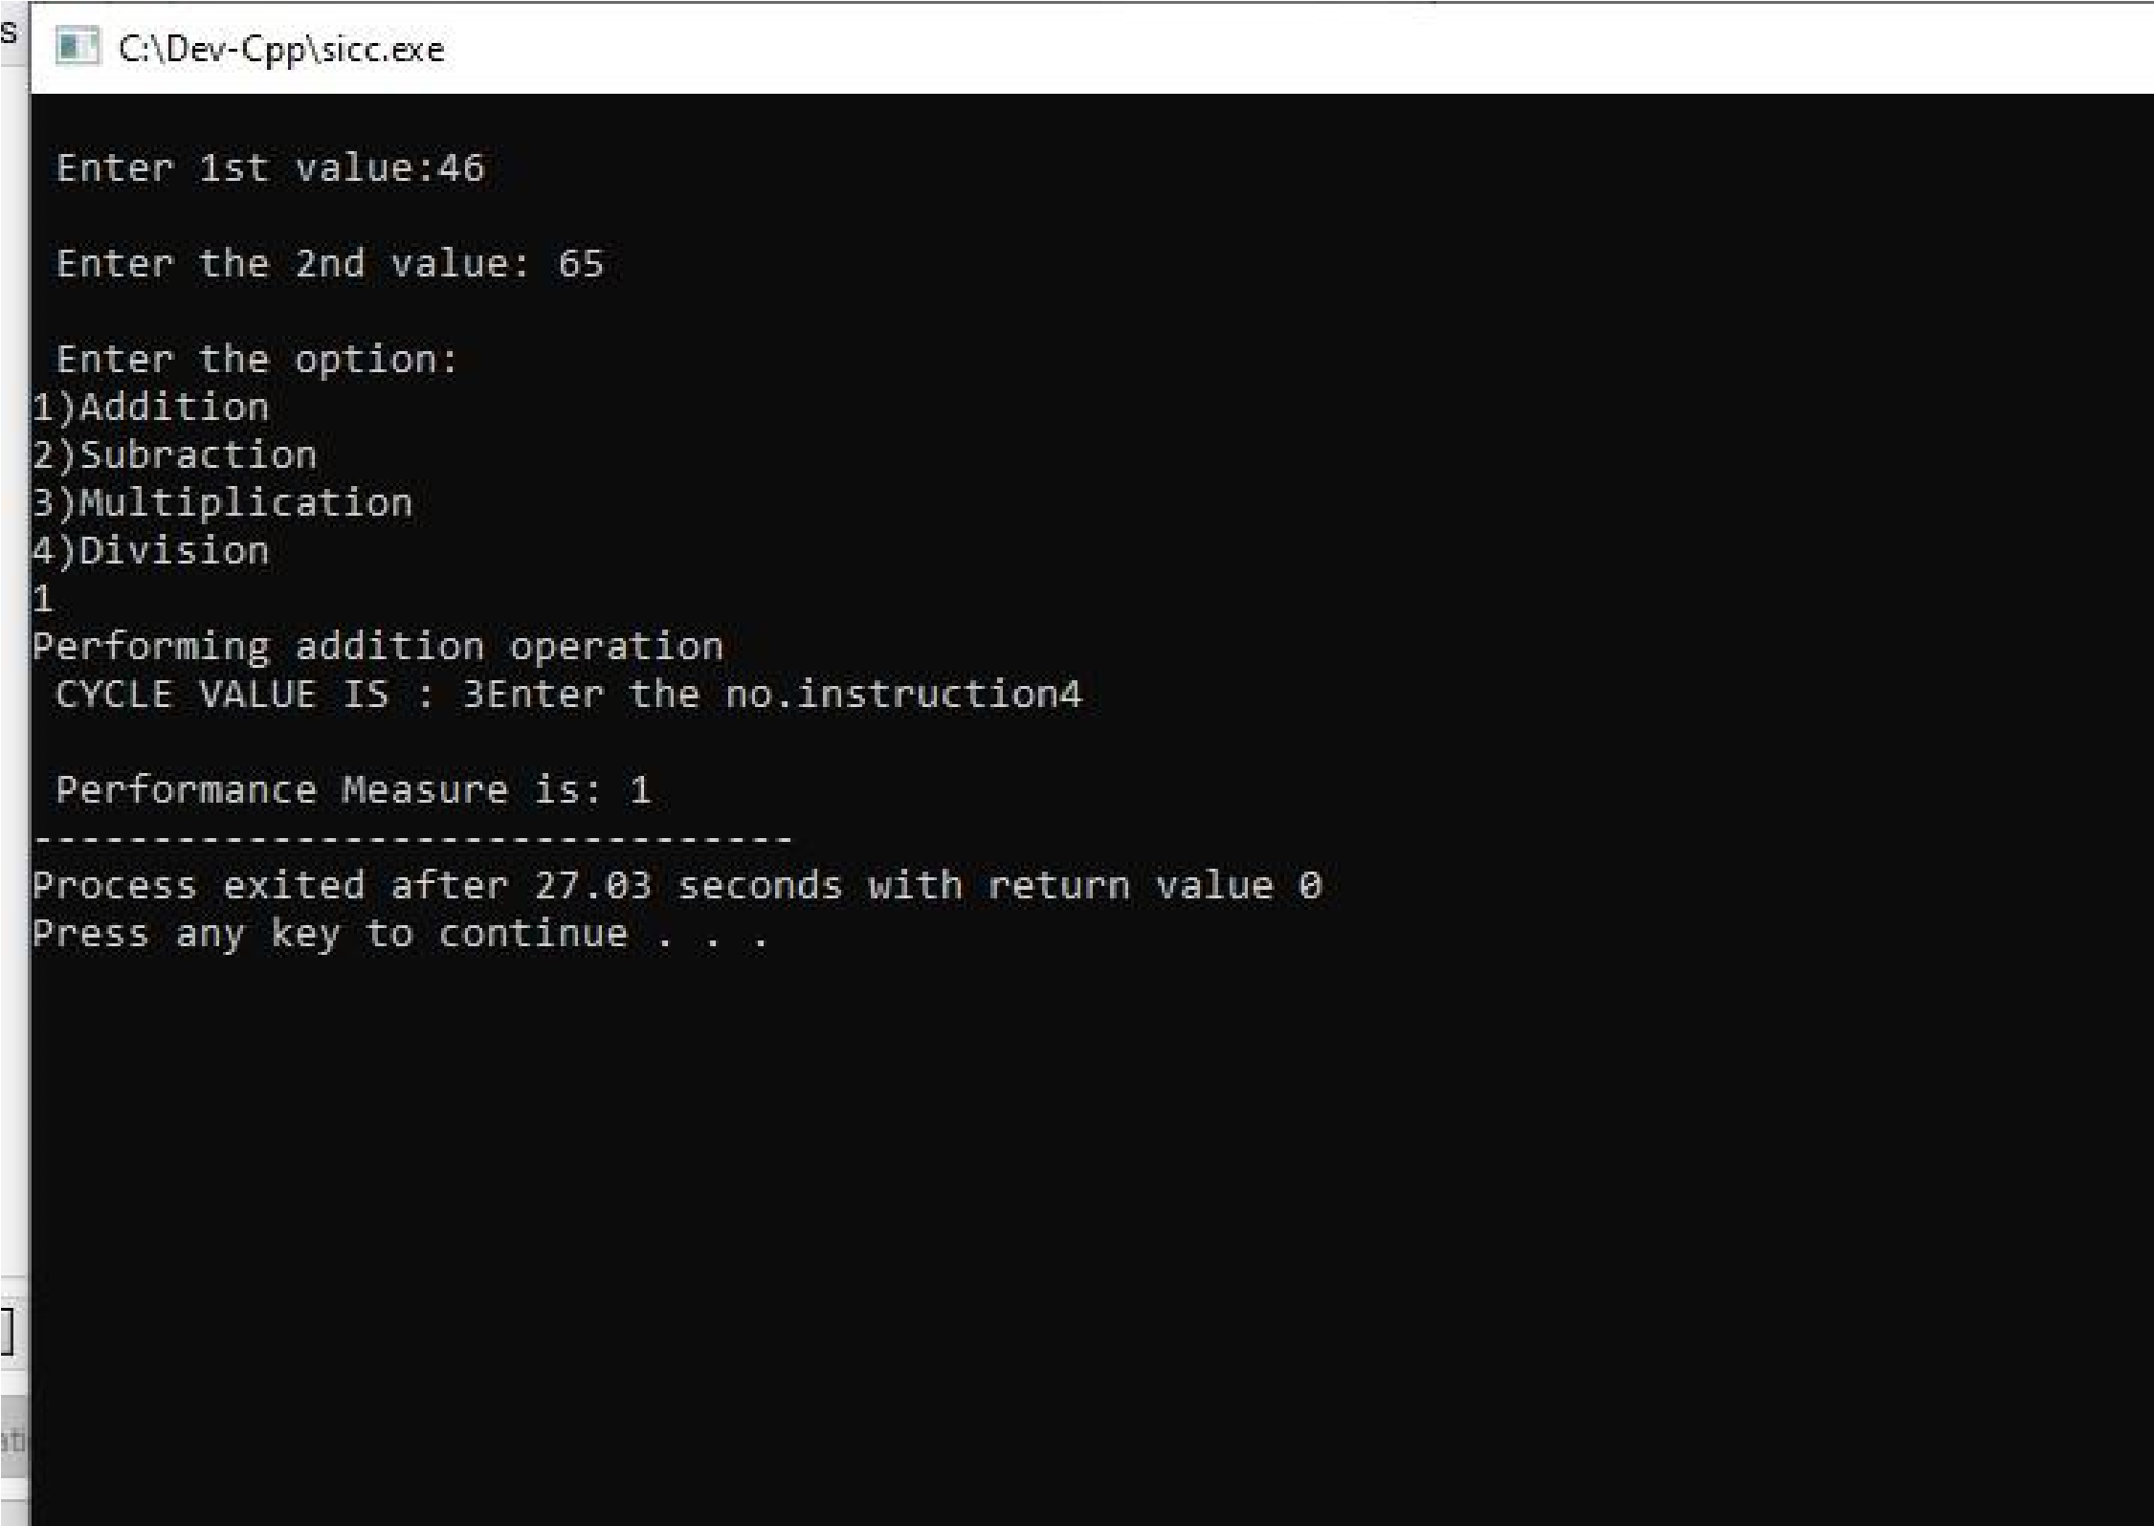**RESULT:** Thus the program was executed successfully using DevC++.